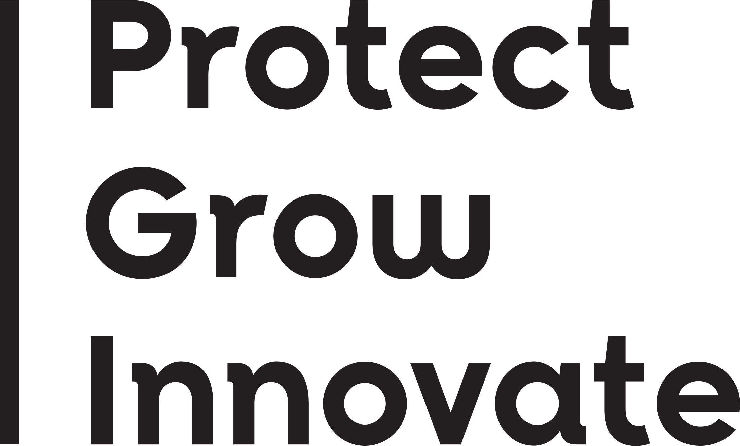


Project Completion Report

Wildlife Animal Ethics Committee (WAEC)
- Current WAEC approval number: | WAEC XX-XX-XX
- Project title:
- Project duration: | Date from – Date to
- Chief Investigator (CI):
- Project outcomes:
Please list the aims of the project and provide a summary of the outcomes for each of the aims over the life of the project.
Information provided in this section should assist the Committee in assessing how well the project delivered against the aims and objectives and provide a summary of what has been learnt during the project. Under the Code, a project must demonstrate its value to ensure the potential effects on the wellbeing of animals is justified.
It should include information on how the data collected has or will contribute to your understanding of the species, systems or impacts you are investigating.
Aims:
Summary of Outcomes:
Please also list any other information or achievements for the project:
- For any future projects you undertake, are there any learnings obtained arising from the outcomes?
- List and attach publications/reports derived from this project:
Please email completed form to wildlifeaec@dpird.wa.gov.au

