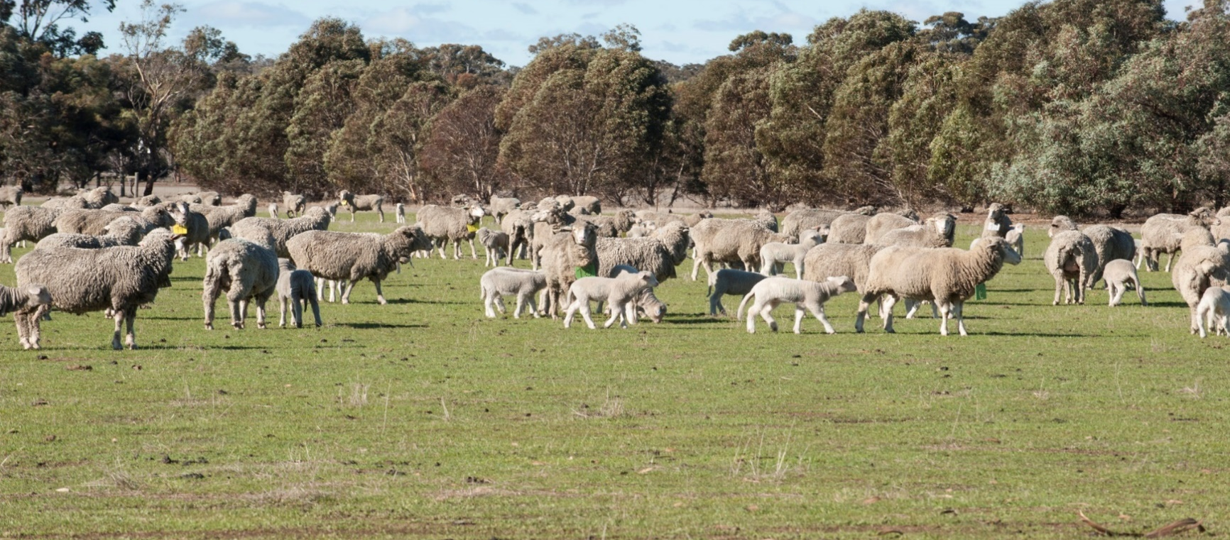


DPIRD AEC - Proposal to use Animals for Scientific Purposes

Project and Funding Information
Trial/activity number | Provided to you by the DPIRD Animal Ethics Office.
Title of activity
Principal Investigator
Animal Usage Start | Click or tap to enter a date.
Animal Usage End | Click or tap to enter a date.
Research Activity or Demonstration?
Purpose | Choose an item.
Procedure | Choose an item.
Does this activity relate to a previously approved application? | Yes ☐ No ☐  If yes, what is the AEC number:
Funding Body
Related Activities
Sufficient funds for the duration of this project? | Yes ☐ No ☐
Inter Institutional Agreement? | Yes ☐ No ☐
Conflict of interest? | Yes ☐ No ☐

Team
Resource | Role | Organisation | Contact
Who? | What is their role? | Which institution? | Contact details.

Location of Activity
Address of Property | Privately Owned? | Leased?
 | ☐ | ☐
 | ☐ | ☐
 | ☐ | ☐
 | ☐ | ☐
 | ☐ | ☐
 | ☐ | ☐
 | ☐ | ☐

Project Design, Purpose and References
Glossary
Please provide layman’s definitions of all scientific/abbreviated terms here in the glossary.

Introduction and Background
In layman’s terms (plain English), please give some background to your research activity. Start very general and basic, as if you were explaining it and giving context to someone off the street who had no idea about anything you do. Please in-text reference.

Was biometric endorsement required for this trial? Yes ☐ No ☐
If Yes, please write a short description of what was discussed:

If No, justify why no biometrician:

Outcomes
Please relate your activity to DPIRD’s strategic outcomes, found here: Strategic Outcomes 2022-26

Hypothesis
Scientific hypothesis. If your activity is a Demonstration, please write N/A.

Research Aim
If your activity is a Demonstration, please write N/A.

Objective
Activity objectives.

Experimental Design
The plan to test your hypothesis. Remember to define all scientific terms in the Glossary.

Detailed Methods
The detailed/more scientific version of what you will be doing.

Originality
How original is this research? Has it been done before, is it the first of its kind?

References
Bibliography of all references used from introduction through experimental design.

Death as an Endpoint
Does death as an endpoint form part of this activity?
Please describe how the deaths will occur, how they’ll be managed, and how high welfare standard will be maintained?

Animal Details and Numbers
If there is a related species that could be used, please explain why not used?

Maximum number of animals to be used over period of the project:

Animals
Year  Please include animals from each year separately | Species  General species, e.g. “Sheep” | Sex | Usage  New, Re-used or Co-used? | Source  Select from drop-down. | Type  Select from drop-down. | Privately  Owned | Leased | # of Animals Used | Fate of animals | Genetically modified?
 |  |  |  | Choose an item. | Choose an item. | ☐ | ☐
 |  |  |  | Choose an item. | Choose an item. | ☐ | ☐
 |  |  |  | Choose an item. | Choose an item. | ☐ | ☐
 |  |  |  | Choose an item. | Choose an item. | ☐ | ☐
 |  |  |  | Choose an item. | Choose an item. | ☐ | ☐
 |  |  |  | Choose an item. | Choose an item. | ☐ | ☐

Animals being used concurrently in another project (Co-Use)? Yes ☐ No ☐
If Yes:
Have the animals recovered from their previous activity?
Describe any pain or distress caused specifically by the animals undergoing multiple procedures.
Total time animals will be co-used (in days):

Animal Relocations
# of Animals | Date  Can be approximate. | Location From | Location To | Transport Type  e.g. truck, walk, ute. | Transport Details  Any other details.

Procedures – please list all procedures done to the animals including routine husbandry
Type | Procedure Name | SOP #  If one exists. | Procedure Description  If you do not have an approved SOP for this procedure, detail is required. | Frequency  Times per days, hours, weeks? | Substance  Drug, etc. | Dosage | Route Administered | # of Animals | Main Operator | Additional Operators
Choose an item.
Choose an item.
Choose an item.
Choose an item.
Choose an item.
Choose an item.
Choose an item.
Choose an item.

Measurements and Observations
Measurement or Observation  What will you be measuring for your research? | Application  How will you measure it? | Frequency  How often? | Unit  In what units? | Notes

Addressing the 3R’s

Replacement
How have you tried to replace the need for animals to achieve this research?
Reduction
How have you tried to use fewer animals while still maintaining statistical validity?
Refinement
How have you chosen methods that alleviate or minimise pain and distress in animals, or enhanced their wellbeing?

Expected Deaths
Potential Cause of Death | Impact on Welfare | Steps Taken to Minimise Impact | % of Animals Affected

Fate of Distressed or Injured Animals
Registered Vet Surgeon Consulted?  If No, why not? | Describe decision making process to treat or euthanise | Will Pentobarbital Sodium be used? | Fate of Animals  Euthanasia by what? Removal from research? | Disposal of Animal Body

Critical Limits
Parameter | Critical Limit  Include a percentage of animals affected above which will be cause for concern. | Actions
Choose an item.
Choose an item.
Choose an item.

Animal Welfare Monitor Planned Inspections
Date  Leave if unsure. | Frequency | Responsibility  AWM or yourself (self-report)? | Purpose | Information to be provided

Animal Welfare Risks
Risk Name | Responsibility | Monitoring Start Date | Planned Inspection Frequency | Monitoring Method

Health, Safety and Chemicals

Explain and describe the risks to other animal or people health, and the precautions taken:

Describe biosecurity procedures that will be undertaken:

Will veterinary chemicals be used in this activity? Yes ☐ No ☐
If Yes, will veterinary chemicals be used in accordance with the labels?
Yes ☐ No ☐
AVPMA Permit number:

Is this a continuation of an approved DPIRD AEC research activity?
If Yes, AEC #:

Threatened Fauna, Environmental Protection and BCA Act 1999
Is this target species listed under the Environmental Protection and Biodiversity Conservation Act 1999 as threatened? If Yes, justify why it is being used.

If required, do you have Biodiversity Conservation Act 2016 Authorisation:
Yes ☐ No ☐

Further Information

Is this activity using genetically modified animals?
Yes ☐ No ☐
Describe:
Does this activity have potential IP complications?
Yes ☐ No ☐
Describe:
Production of commercial products or services?
Yes ☐ No ☐
Describe:
Provision of prescriptive advice?
Yes ☐ No ☐
Describe:
Principal Investigator Declaration
I hereby declare that:
The Code:
I have read, understood and agree to abide by the Australian Code for the Care and Use of Animals for Scientific Purposes 8th Edition; including Chapter 2.4: Responsibilities of investigators.
I confirm that I will conduct the research in accordance with AEC approval and in compliance with the Code.
I will continue to consider the three Rs throughout the duration of the project.
All animals in this activity will receive humane and proper treatment in accordance with this proposal and the expectations of DPIRD, the AEC and the Code.
Research Personnel Responsibilities:
I understand that as the Principal Investigator, I have ultimate responsibility for the conduct of the activity and/or the care of the animals.
I will ensure that all people involved in the activity understand and accept their roles and responsibilities.
I will ensure all activity personnel are aware of and understand the techniques, methodology and any conditions approved for this project and any relevant Standard Operating Procedures.
Personnel identified as competent animal handlers have the qualifications, experience and training required for all procedures and species identified for the project and the competency to deal with adverse events should they occur.
Supervised training by a competent and trained person will be provided for all personnel who do not have the required level of skill and experience, and evidence of this will be submitted to the Office before the animal use starts/before the team member starts handling animals.
Research Activity Resources (funding and personnel):
Where appropriate, I have discussed the resourcing and feasibility of this activity with the relevant Facility Manager, Cost Centre Manager and Line Manager.
Adequate resources will be available to ensure that the activity is conducted according to the proposal’s approval and conditions and animal welfare is not compromised.
Unexpected adverse events:
I agree to notify the AEC within 24 hours of any adverse event relating to this project.
Amendments:
I understand that no part of the approved project may be changed without prior AEC approval.
Permits, Licenses, and Chemical Use:
I will abide with the requirements for the acquisition, retention or use of the animals subject to any permit, law or regulation of the State or Commonwealth.
Veterinary chemicals will be used in accordance with ALL directions, withholding periods and warnings detailed on the product label and/or permit. Any off-label use must be conducted in accordance with the relevant legislation.
I acknowledge that all the information contained in the application form is a true and accurate record.
Principal Investigator Full Name:
Signature:
Date:
Important Disclaimer
The Chief Executive Officer of the Department of Primary Industries and Regional Development and the State of Western Australia accept no liability whatsoever by reason of negligence or otherwise arising from the use or release of this information or any part of it.
Copyright © State of Western Australia (Department of Primary Industries and Regional Development), 2024.

